APPS and other Tools for General Civility

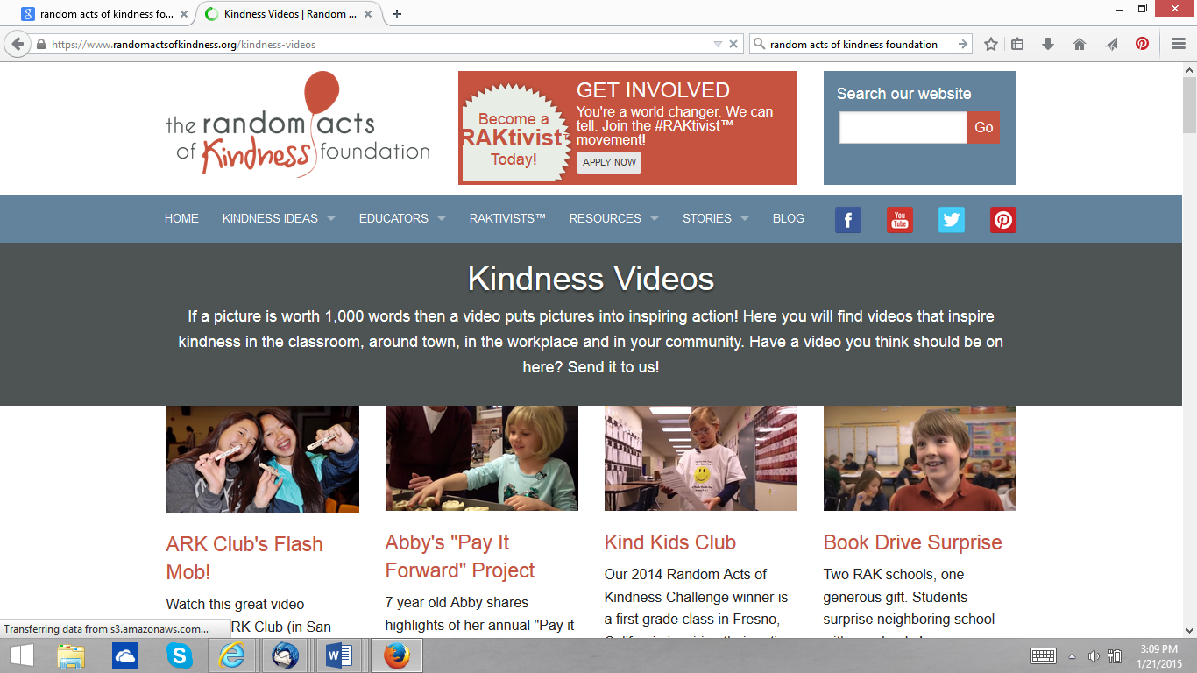
Kindness Videos; https://www.randomactsofkindness.org/kindness-videos

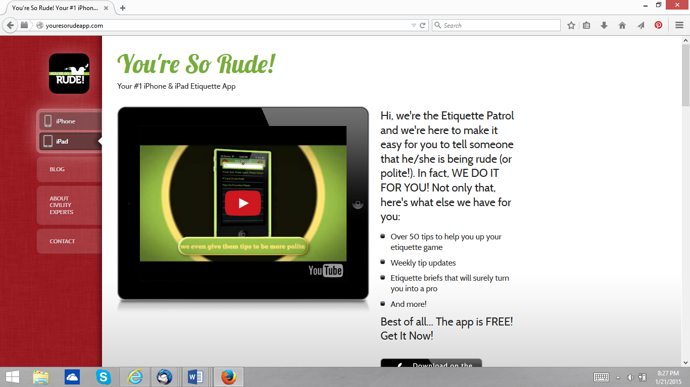
http://youresorudeapp.com/
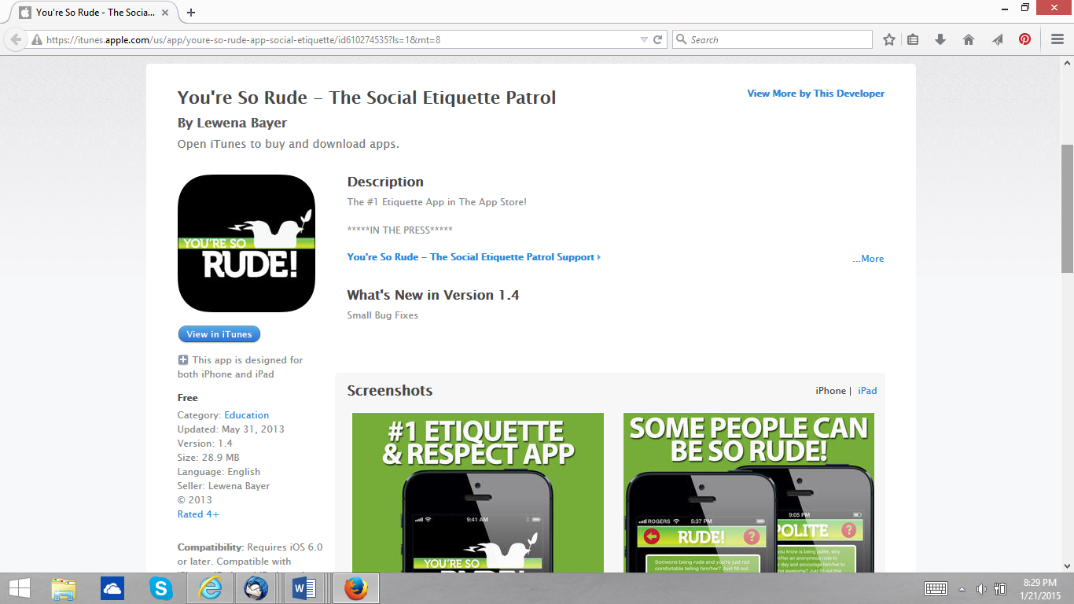
https://itunes.apple.com/us/app/youre-so-rude-app-social-etiquette/id610274535?ls=1&mt=8

Mind Your Manners with Etiquette Survival Guide App for iPhone

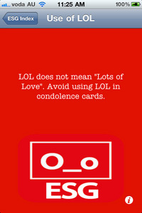
http://appscout.pcmag.com/apple-ios-iphone-ipad-ipod/268794-mind-your-manners-with-etiquette-survival-guide-app-for-iphone By BrothaTech
The Etiqette Survival Guide (ESG) is a user-submitted database of reference subjects that will either get you out of a weird, awkward, or potential "foot in your mouth" situation, or give you some laughs as you flip through some of the subjects and view the ESG's answers. Subjects range from:
-Internet
-Meeting the Parents
-Driving
-Hosting
-Public Transport
-Pub
-Shotgun
-Bathroom
The ESG is user-submitted guide, meaning if you have some suggestions on how to [correctly] handle certain subjects, you simply shoot an email to the developers and your solution to "whether or not to friend an Ex on Facebook" may just be seen by other users of the app.The Etiquitte Survival Guide is a free app in the iTunes App Store (OS 3.2 and up).

